**Documentation for Shading Milestone**

The difference in energy loss estimates between SunEye measurements and SAM 3D shading calculations relative to baseline annual energy production for three systems were calculated. The goal of the milestone is met on this basis, in that the difference in annualized energy loss estimates based on 3D shading calculations is less than 10% different from the losses predicted by SunEye measurements.

|  |  |  |  |  |  |  |
| --- | --- | --- | --- | --- | --- | --- |
| **System** | **Location** | **System Size** | **Baseline kWh Annual** | **Lost energy (via SunEye)** | **Lost energy (via 3D)** | **Difference in energy loss estimates** |
| Ivanhoe | Denver | 3.6 kW | 5478 | 738 | 785 | 6.37% |
| Babbitt | Los Angeles | 4 kW | 5659 | 326 | 296 | 9.2% |
| Halstead | Los Angeles | 4 kW | 6427 | 361 | 329 | 8.86% |

The example of the Ivanhoe system modeled in the SAM 3D shade estimator is shown below.

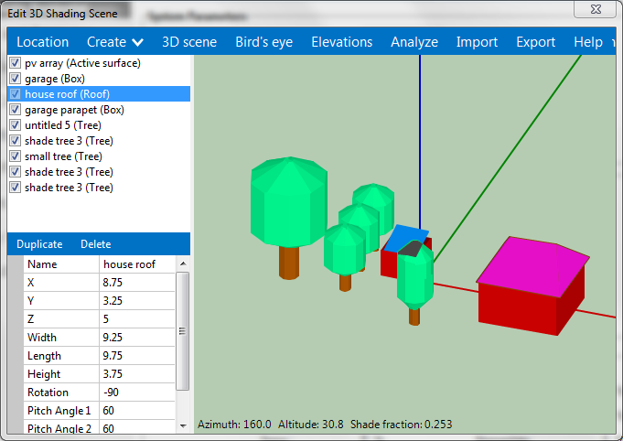

Ivanhoe

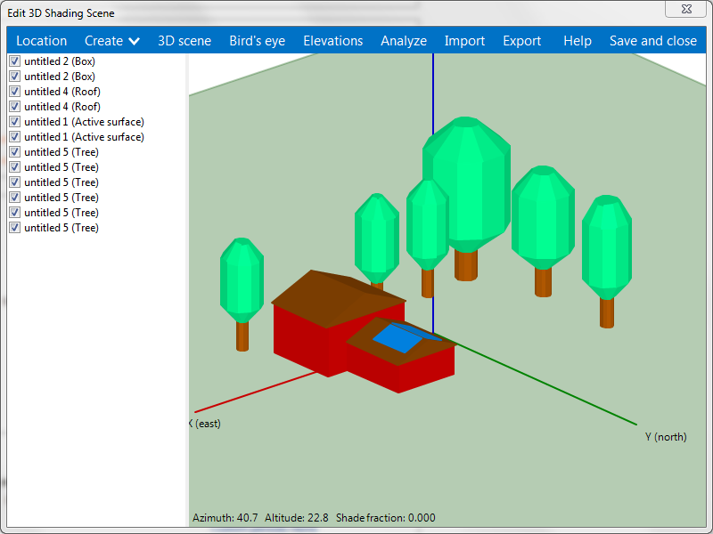

Babbitt

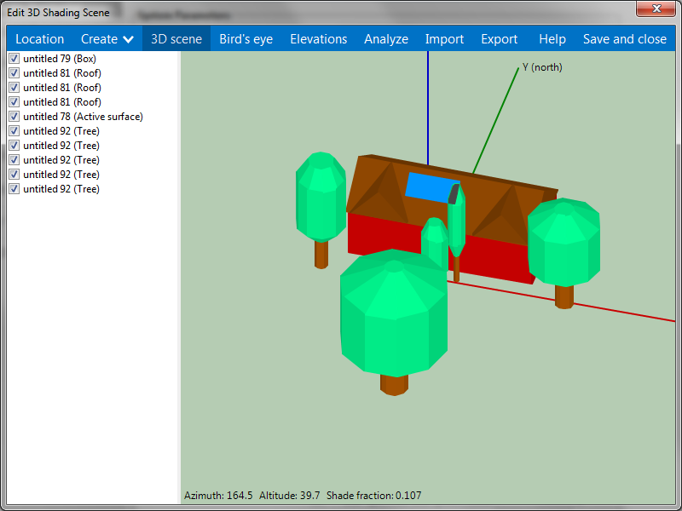

Halsted